EX. NO.: 16

HIGH LEVEL PROGRAMMING EXTENSIONS – PROCEDURES
AIM
To learn how to create and execute stored procedures in MySQL.

PROCEDURE
- Select the MobileDB database.
- Create a stored procedure using the CREATE PROCEDURE statement.
- Write the required SQL statements inside the procedure.
- Use the CALL statement to execute the procedure.
- Display the result of the procedure.
- Observe and verify the output.

PROGRAM-1
Create a procedure to display all records from the MobileSales table.
1. Select Database
USE MobileDB;
2. Create Procedure
DELIMITER //

CREATE PROCEDURE DisplayMobiles()
BEGIN
SELECT * FROM MobileSales;
END //

DELIMITER ;

3. Execute the Procedure
CALL DisplayMobiles();

PROGRAM-2
Create a procedure to display mobiles whose price is greater than a given price.
1. Create Procedure with Parameter
DELIMITER //

CREATE PROCEDURE MobilesAbovePrice(IN min_price INT)
BEGIN
SELECT MobileName, Price, CustomerReview
FROM MobileSales
WHERE Price > min_price;
END //

DELIMITER ;

2. Execute the Procedure
CALL MobilesAbovePrice(30000);

3. Execute with Another Price
CALL MobilesAbovePrice(25000);

OUTPUTS

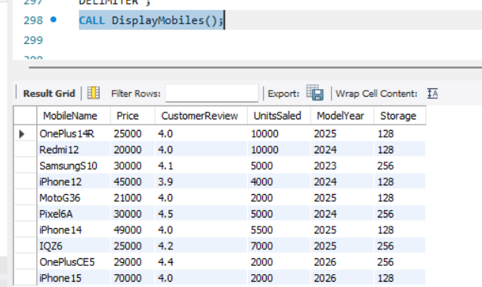

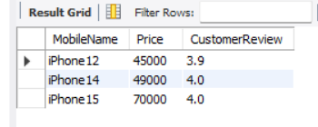

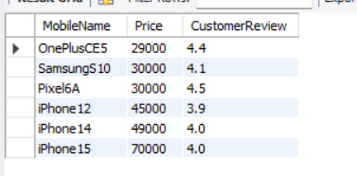

RESULT
Thus, the stored procedures were successfully created and executed using MySQL, and the required records were displayed successfully.

